🧪 Lab 1: Organize Application Logs
Scenario
The /logs folder is cluttered. Organize logs into a backup folder.
Tasks
mkdir file_lab
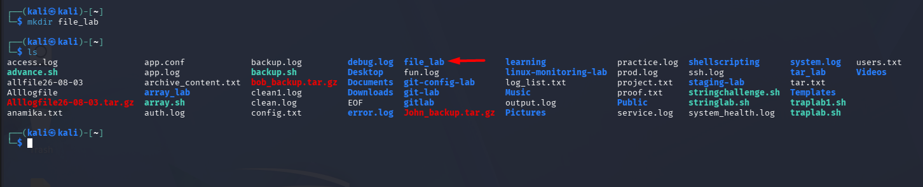
cd file_lab
touch app.log error.log access.log config.conf notes.txt
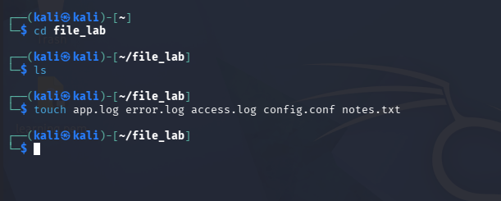
mkdir logs_backup
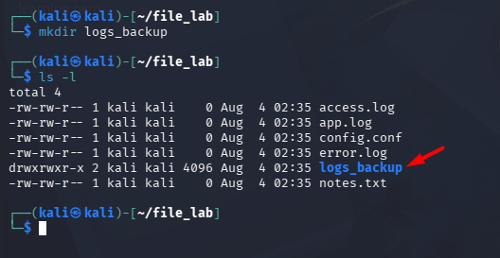
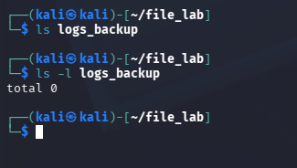
mv *.log logs_backup/
ls
ls logs_backup
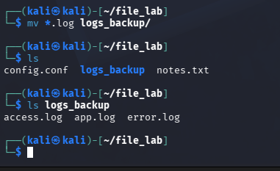

Skills
- mkdir
- mv
- Wildcards (*.log)
- Directory organization

🧪 Lab 2: Create Project Directory Structure
Scenario
A new web application project is starting.
Tasks
mkdir -p webapp/{config,logs,scripts,backup,data}
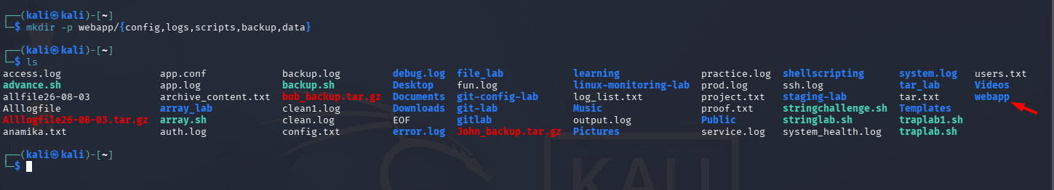
tree webapp
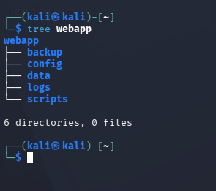
If tree is unavailable:
find webapp
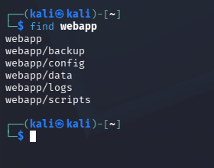
Expected Structure
webapp
├── backup
├── config
├── data
├── logs
└── scripts

🧪 Lab 3: Search Configuration Files
Scenario
Find all .conf files.
Commands
mkdir config_lab
cd config_lab
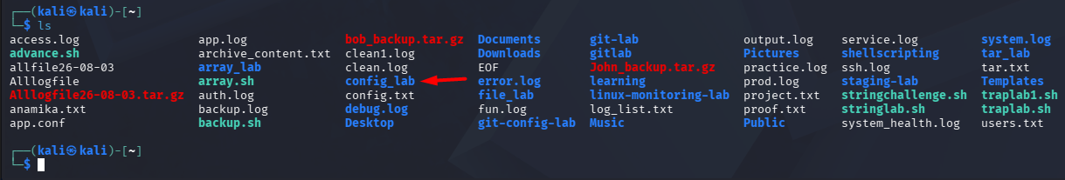

touch app.conf nginx.conf database.conf notes.txt
find . -name "*.conf"
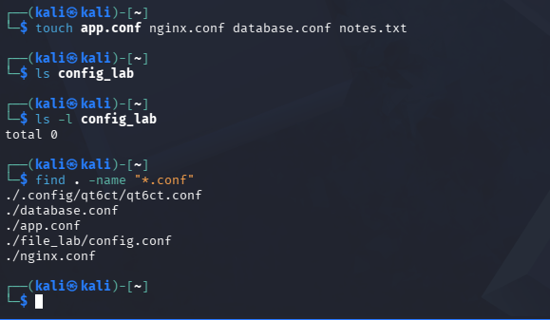

🧪 Lab 4: Copy Backup Before Deployment
Scenario
Before modifying a configuration file, create a backup.
echo "PORT=8080" > app.conf
cp app.conf app.conf.bak
ls
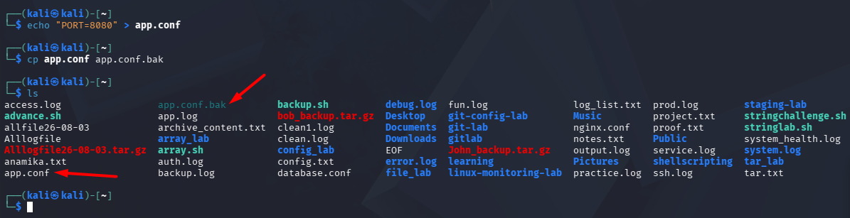

🧪 Lab 5: Rename Log Files
Scenario
Rename today's log before archiving.
touch application.log
mv application.log application_old.log
ls
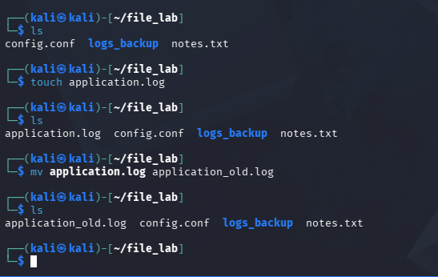

🧪 Lab 6: Remove Old Temporary Files
Scenario
Clean up temporary files.
touch temp1.tmp temp2.tmp temp3.tmp
rm *.tmp
ls
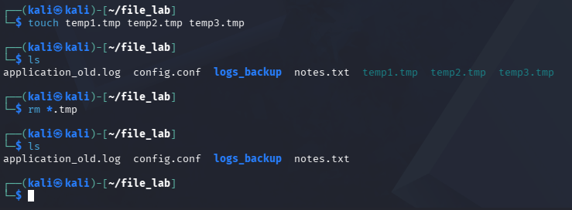

🧪 Lab 7: Find Large Files
Scenario
Find files larger than 1 MB.
find /home -type f -size +1M
(You can also create a test file with dd if needed.)
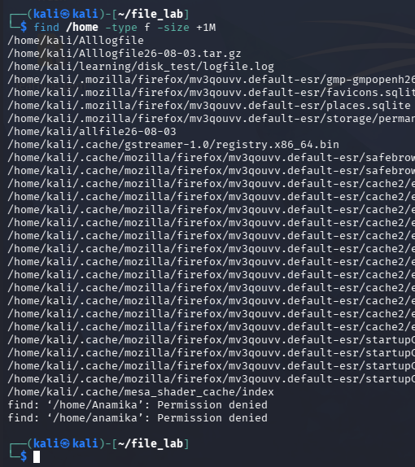

🧪 Lab 8: Archive Project Folder
Scenario
Archive the project before deployment.
mkdir project
touch project/app.py
touch project/config.yml

tar -czvf project_backup.tar.gz project/ -------- Create + Zip + Verbose + File
tar -tzvf project_backup.tar.gz -------- Table + Zip + Verbose + File
tar -xzvf project_backup.tar.gz -------- Extract + Zip + Verbose + File

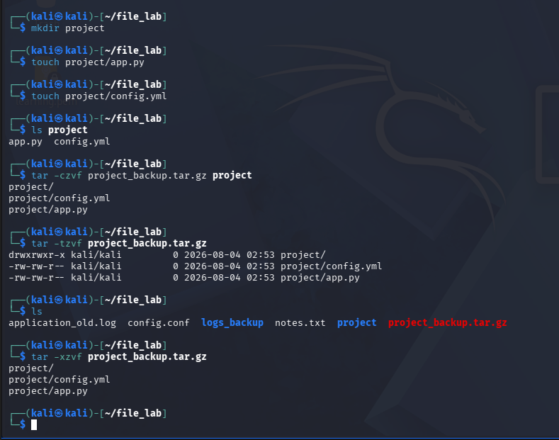

🧪 Lab 9: Find Recently Modified Files
Scenario
Identify files modified in the last day.
find . -mtime -1
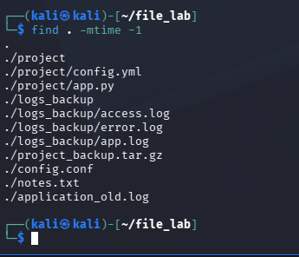

🧪 Lab 10: Check Disk Usage by Directory
Scenario
Find which folder is consuming disk space.
du -sh *
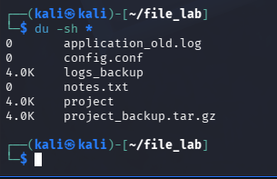
du -sh .
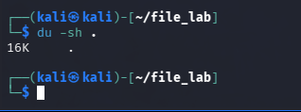

🧪 Lab 11: Hidden Files Management
Scenario
View hidden configuration files.
touch .env .gitignore
ls -la
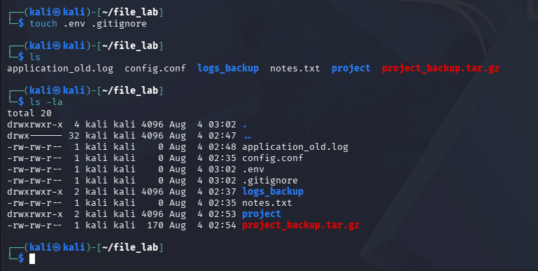

🧪 Lab 12: Simulate Accidental Deletion & Recovery
Scenario
A user accidentally deletes project files, but a backup exists.
mkdir project

touch project/index.html
touch project/style.css
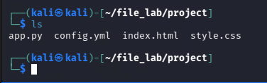

cp -r project project_backup : Copy the project folder to project_backup
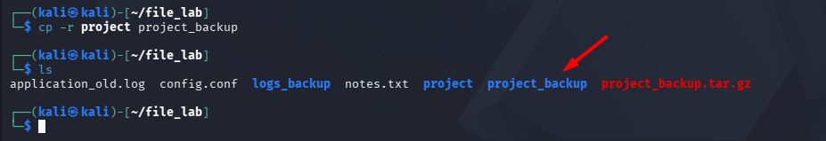
rm -rf project : Remove the project folder
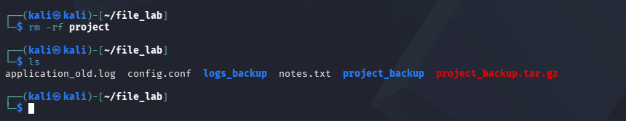
cp -r project_backup project : Copy the project_backup folder to project back
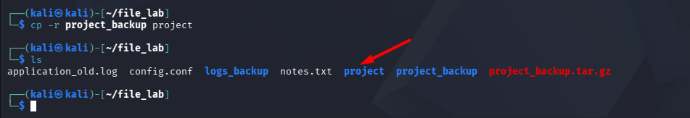

🎯 Resume Highlights
After completing these labs, you can confidently add:
- Linux File & Directory Management
- File Search & Organization (find, mv, cp)
- Directory Structure Creation
- Backup & Restore Operations
- Log File Management
- File Archiving (tar)
- Disk Usage Analysis (du)
- Hidden File Management
- File Cleanup & Maintenance
- Production-style File Operations

